Gratitude Tree
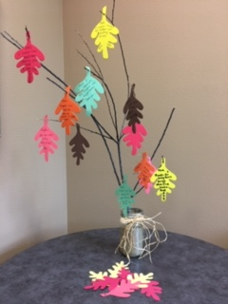
Purpose:
To share and receive expressions of gratitude with those in our family, support circle and our deceased loved one
Materials Needed:
- Large glass jar
- Sand
- Branch
- Construction paper or foam sheets – various colors
- Markers- various colors
- One-hole punch
- Raffia or other ribbon
Grateful Tree Instructions:
Fill the jar ¾ full with sand. Stick the branch into the sand and have it stand up like a tree. Using Construction paper or foam sheets, cut out leaf shapes. (You can print off leaf images online and use these as templates.) Use the one-hole punch to make a hole in the stem of your leaves to hang on the tree.
Facilitation of Activity:
“Thanksgiving is a time where we pause and give thanks for what we have. When we experience a loss, the people in our lives are more important than ever in helping us move through our grief. These people may be our family members, friends, extended family, neighbors, etc. We also want to share our appreciation for the person in our lives that died, as they continue to hold a place in our lives”. On Thanksgiving day, each person gets as many leaves as there are people seated at the table , plus an extra leaf each for your deceased loved one. (eg. If there are four people at the table, each person would get 5 leaves. Using the markers, everyone writes down on the leaves something they are thankful for, for each person. The group then takes turns reading out loud what they wrote on the leaf and hangs it on the tree. Soon the tree will be filledl with color and the richness that represents out natural support system.

